**Frontend Development with React.js**

**Project Documentation – Rhythmic Tune**

1. Introduction

* Project Title: Rhythmic Tune
* Team Members:
  + - Gopika .L(Code exection)
    - Kaviya .M(Demo video)
    - Kavipriya .P(Demo video)
    - Monika .S(Documention)

2. Project Overview

Purpose:

Rhythmic Tune is a music-based web application that allows users to explore, play, and organize their favorite tunes. It provides a smooth, interactive, and visually appealing interface for discovering songs and creating playlists.

Features:

* Music player with play, pause, next, and previous controls
* Playlist creation and management
* Search functionality for tracks/artists
* Responsive UI for mobile and desktop
* Dark/Light mode support

3. Architecture

* Component Structure:
  + - App.js – Root component
    - Navbar.js – Navigation bar
    - MusicPlayer.js – Core music player controls
    - Playlist.js – Playlist management
    - SearchBar.js – Search functionality
    - SongCard.js – Individual song display
* State Management:
  + - Context API is used for global state (e.g., currently playing song, playlists).
* Routing:

React Router is used with routes such as:

* + - Home (trending tunes)
    - playlist – User playlists
    - search – Search result

4. Setup Instructions

* Prerequisites:
  + - * Node.js, npm, Git
* Installation:
  + - git clone <https://github.com/your-repo/rhythmic-tune.git>
    - cd rhythmic-tune
    - npm install
    - npm start

5. Folder Structure

* Client:
  + - src/
    - components/
    - Navbar.js
    - MusicPlayer.js
    - Playlist.js
    - SongCard.js
    - pages/
    - Home.js
    - Search.js
    - Playlist.js
    - assets/
    - images/
    - icons/
    - utils/
    - helpers.js
* Utilities:
  + - Helper functions for API calls and reusable hooks.

6. Running the Application

* Frontend:
  + - npm start

7. Component Documentation

* Key Components:
  + - MusicPlayer – Handles audio controls, progress bar, volume.
    - Playlist – Stores and displays songs added by the user.
    - SearchBar – Allows searching for tracks/artists.
* Reusable Components:
  + - SongCard – Displays song details consistently across pages.
    - Button – Custom reusable button component.

8. State Management

* Global State:
  + - Current track, playlist data, theme (dark/light).
* Local State:
  + - Input fields for search, toggle states for UI elements.

9. User Interface

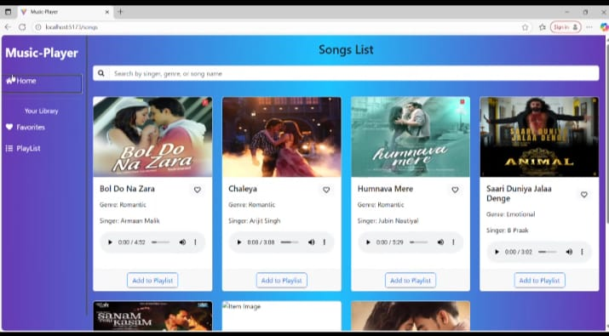

10. Styling

* CSS Frameworks/Libraries:
  + - Tailwind CSS for styling
    - Styled-Components for scoped CSS.
* Theming:
  + - Dark/Light theme toggle with persistent local storage.

11. Testing

* Testing Strategy:
  + - Unit testing with Jest for core functions
    - Component testing with React Testing Library
    - Integration testing for player and playlist
* Code Coverage:
  + - Measured using Jest coverage tools.

12. Screenshots or Demo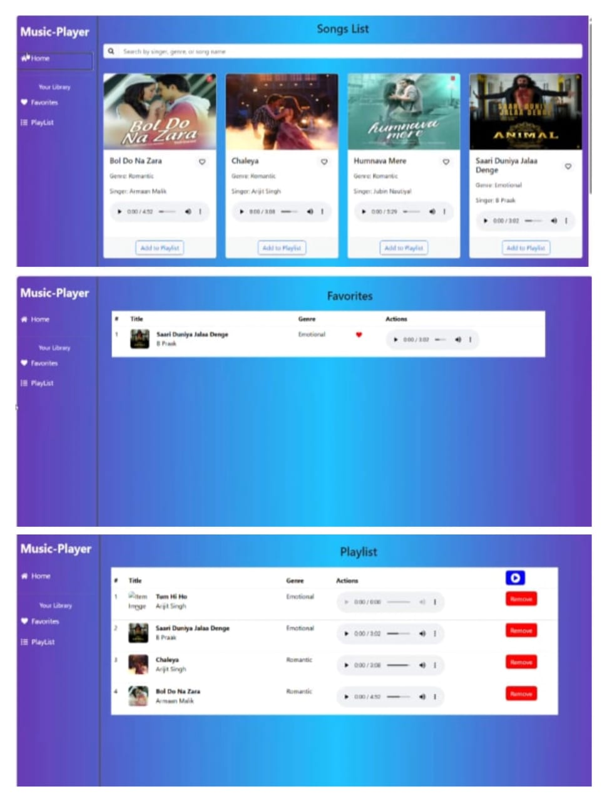

13. Known Issues

* Limited offline support.
* Audio may lag on very low-end devices.
* Currently supports only basic playlist features (no sharing)

14. Future Enhancements

* Add user authentication for personalized playlists.
* Support for offline playback.
* Integration with third-party music APIs (Spotify, SoundCloud).
* Advanced audio visualizations and animations.
* Social features – share playlists with friends.